Q1: Directory Setup
1. Go to your home directory.
2. Create a folder named path_lab .
3. Inside path_lab , create two directories:
absolute
relative
4. Inside relative , create a file named test.txt .
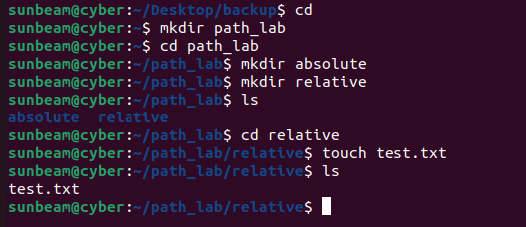
Q2: Absolute Path Practice
1. From any directory, navigate to path_lab using an absolute path.
2. Move to the relative directory using an absolute path.
3. Display the content of test.txt using its absolute path.
4. Create a new file abs.txt inside the absolute directory using absolute path
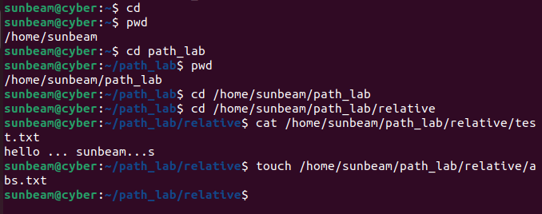

Q3: Relative Path Practice
1. Go to path_lab directory.
2. Move to relative directory using relative path.
3. Go back to path_lab using ..
4. Create a file rel.txt inside relative using relative path.
5. Display test.txt without changing the current directory.
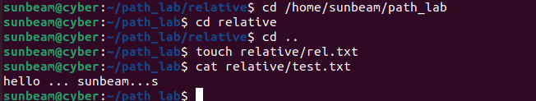

Q5: Navigation Using . and ..
1. Stay inside relative directory.
2. Print the present working directory.
3. Use . to list files in current directory.
4. Use .. to list files in parent directory.
5. Create a file in absolute directory while staying in relative .
